

**Course: Software Engineering Project-1 (using C)**

**Course Code: SWE 231**

**PROJECT REPORT**

**CGPA MANAGEMENT SYSTEM OF DIU (SWE Dept)**

**Submitted By**

ANIK SARKER

153-35-1337

WASHIQ ANWAR SHAMSI

153-35-1366

Group: 13(B)

**Under Supervision**

Mr. Kaushik Sarker

Lecturer Department of Software Engineering

**CONTENTS**

**1.Acknowledgement……………………………………………………………………………………… 04  
2. Abstract…………………………………………………………………………………………………….. 04  
3. Requirement analysis ………………………………………………………………………………… 05**

* Feasibility Study…………………………………………………………….05
* Requirement Gathering……………………………………………………...05
* Requirement Specification…………………………………………………..05
* Requirement Validation ……………………………………………………..06

**4. Design and plan …………………………………………………………………………………………. 07**

* Use case Diagram……………………………………………………………………………………. 07
* Flow Diagram………………………………………………………………………………………….. 08

**5. Implementation …………………………………………………………………………………………. 09  
6. Testing of the project…………………………………………………………………………………. 17  
7. Strong and weak points of the project……………………………………………………….. 19  
8. Evaluation of learning experience………………………………………………………………. 19  
9. Conclusion/ Future work……………………………………………………………………………. 20**

**Following DIU Grade chart is considered to make the system :**

|  |  |  |
| --- | --- | --- |
| Marks obtained out of 100 | Grade point Equivalent | Grade |
| 80% and above | 4.00 | A+ |
| 75% to less than 80% | 3.75 | A |
| 70% to less than 75% | 3.50 | A- |
| 65% to less than 70% | 3.25 | B+ |
| 60% to less than 65% | 3.00 | B |
| 55% to less than 60% | 2.75 | B- |
| 50% to less than 55% | 2.50 | C+ |
| 45% to less than 50% | 2.25 | C |
| 40% to less than 45% | 2.00 | D |
| Less than 40% | 0.00 | F |

**Acknowledgement**

First of all we want to thank Mr. Kaushik Sarker for his awesome guidance during this project course. We also get a lot of help from the book " Let us C" written by yashwant kanetkar who is a Indian computer programmer .We also take many helps from many online sources during our project work we faced many little problems while we were working on our codes. We used code blocks IDE for completing our project. The big fact is we work a lot together to make the program best. At very first step we collected the DIU main grade sheet and our program is based on this grade chart. After that we designed and planed for the project and Mr.Kaushik Sarker sir helped us a lot in going step by step work.

**Abstract**

In this current time this Application is very useful for all students and teachers. Anyone can use this system as It is very easy to use. Step by step data will be wanted from user and then It will calculate itself and will be given the result and for the future it also create a save file in a specific location that user can view the results later. As a result, it becomes very user friendly!

**Requirement Analysis**

It is a four step process, which includes –

* Feasibility Study
* Requirement Gathering
* Requirement Specification
* Requirement Validation

**Feasibility study**

When the client approaches the organization for getting the desired product developed, it comes up with rough idea about what all functions the software must perform and which all features are expected from the software.

Referencing to this information, the analysts does a detailed study about whether the desired system and its functionality are feasible to develop.

This feasibility study is focused towards goal of the organization. This study analyzes whether the software product can be practically materialized in terms of implementation, contribution of project to organization, cost constraints and as per values and objectives of the organization. It explores technical aspects of the project and product such as usability, maintainability, productivity and integration ability.

The output of this phase should be a feasibility study report that should contain adequate comments and recommendations for management about whether or not the project should be undertaken.

**Requirement Gathering**

If the feasibility report is positive towards undertaking the project, next phase starts with gathering requirements from the user. Analysts and engineers communicate with the client and end-users to know their ideas on what the software should provide and which features they want `

`the software to include.

**Requirement Specification**

SRS is a document created by system analyst after the requirements are collected from various stakeholders.

SRS defines how the intended software will interact with hardware, external interfaces, speed of operation, response time of system, portability of software across various platforms, maintainability, speed of recovery after crashing, Security, Quality, Limitations etc.

The requirements received from client are written in natural language. It is the responsibility of system analyst to document the requirements in technical language so that they can be comprehended and useful by the software development team.

SRS should come up with following features:

* User Requirements are expressed in natural language.
* Technical requirements are expressed in structured language, which is used inside the organization.
* Design description should be written in Pseudo code.
* Format of Forms and GUI screen prints.
* Conditional and mathematical notations for DFDs etc.

**Requirement Validation**

After requirement specifications are developed, the requirements mentioned in this document are validated. User might ask for illegal, impractical solution or experts may interpret the requirements incorrectly. This results in huge increase in cost if not nipped in the bud. Requirements can be checked against following conditions -

* If they can be practically implemented
* If they are valid and as per functionality and domain of software
* If there are any ambiguities
* If they are complete
* If they can be demonstrated

\***Plan and Design**

**Use case Diagram**

Published Result

Result save in a location

Save result

Set marks

Choosing Semester

Name & ID

Teacher

Student

Flow Diagram

Program exit

IF input ==1

Result saved

Press 1 to Save

Save/Exit

Result Box Appear

goto

IF

Enter Mark 0-100

Input <0 || input>100||Invalid key

Add Mark to subject

Input <0 || input>12||Invalid key

Else

Choose Semester

IF

goto

Choose Semester 1-12

Semester list 1-12

Name Input

ID input

Start

**Implementation**

char fname[20],id[20];

printf("\n\t\t\t\t\t\t\t\tID:");

fgets(id,100,stdin);

printf("Name Of The Student:");

scanf("%[^\n]s",fname);

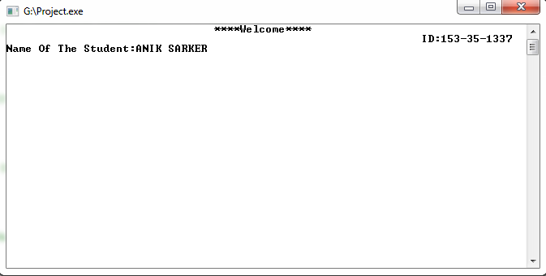

for(i=1;i<=12;i++)

printf("\t\t Semester:%d \n",i);

printf("Chose Semester:");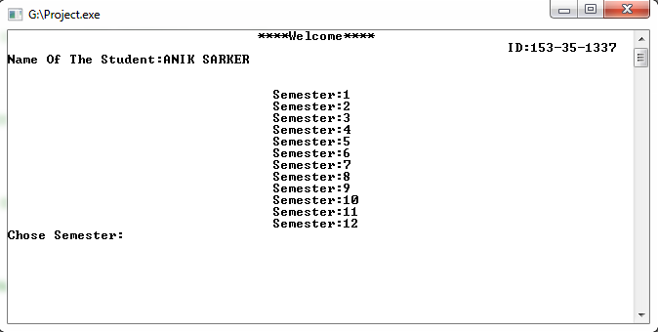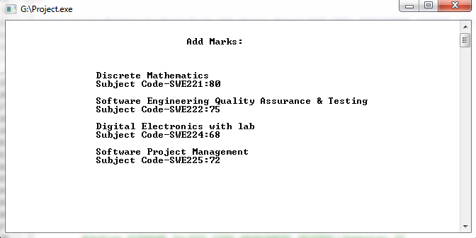

printf("\t\t\t\tDepartment:SWE\n\n");

printf("\t\t\t\t(Semester:5)");

printf("\n\nName:%s \t\t\t\t\t\t ID:%s\n\n",fname,id);

printf("\n\n\tSubject\t\tMarks\t\tGrade Latter\t\tGrade Point\n");

printf("\n\n\tSWE221 \t\t %d\t\t %s\t\t\t %.2f",m,c,k);

printf("\n\n\tSWE222 \t\t %d\t\t %s\t\t\t %.2f",g,d,q);

printf("\n\n\tSWE224 \t\t %d\t\t %s\t\t\t %.2f",s,f,w);

printf("\n\n\tSWE225 \t\t %d\t\t %s\t\t\t %.2f ",h,y,z);

printf("\n\n\n\t\t\t AVERAGE GRADE:%.2f",(k+q+w+z)/4);

**///FOR SAVING OPTION…….**

printf("\n\n\nPress 1 to save The Result\t\t\tPress Any Key for exit\n");

printf("Press Number:");

int save;

scanf("%d",&save);

system("CLS");

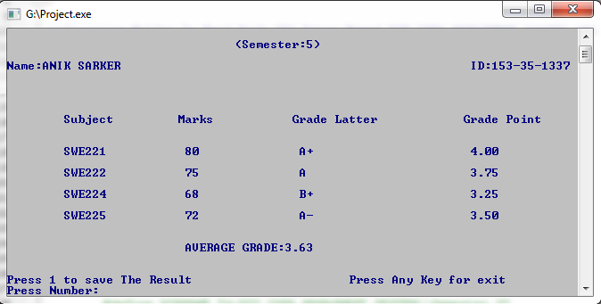

if(save==1)

{

**///File Creating Method -------**

// system("CLS");

char path[]="D:\\DIU CGPA MANAGMENT SESTEM\\Semester 5\\";

strcat(fname,".doc");

strcat(path,fname);

FILE *fp;

fp=fopen(path,"w");

fprintf(fp,"\t\t\t\tDepartment:SWE\n\n");

fprintf(fp,"\t\t\t\t(Semester:5)");

fprintf(fp,"\n\nName:%s \t\t\t\t\t ID:%s\n\n",fname,id); fprintf(fp,"\n\n\tSubject\t\tMarks\t\tGrade Latter\tGrade Point\n");

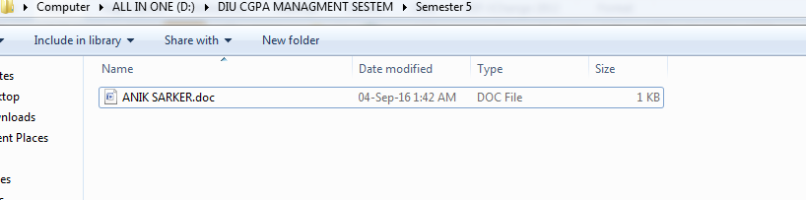 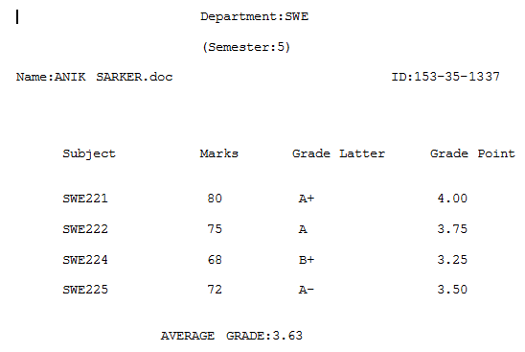

**///Creating directory in a specific location……..**

int f1,f2,f3,f4,f5,f6,f7,f8,f9,f10,f11,f12,f13;

#define DIRNAME"d:\\DIU CGPA MANAGMENT SESTEM"

f1=mkdir(DIRNAME);

if(!f1)

#define DIRNAME "d:DIU CGPA MANAGMENT SESTEM\\Semester 1"

f2=mkdir(DIRNAME);

if(!f2)

#define DIRNAME "d:DIU CGPA MANAGMENT SESTEM\\Semester 2"

f3=mkdir(DIRNAME);

if(!f3)

#define DIRNAME "d:DIU CGPA MANAGMENT SESTEM\\Semester 3"

f4=mkdir(DIRNAME);

if(!f4)

#define DIRNAME "d:DIU CGPA MANAGMENT SESTEM\\Semester 4"

f5=mkdir(DIRNAME);

if(!f5)

#define DIRNAME "d:DIU CGPA MANAGMENT SESTEM\\Semester 5"

f6=mkdir(DIRNAME);

if(!f6)

#define DIRNAME "d:DIU CGPA MANAGMENT SESTEM\\Semester 6"

f7=mkdir(DIRNAME);

if(!f7)

#define DIRNAME "d:DIU CGPA MANAGMENT SESTEM\\Semester 7"

f8=mkdir(DIRNAME);

if(!f8)

#define DIRNAME "d:DIU CGPA MANAGMENT SESTEM\\Semester 8"

f9=mkdir(DIRNAME);

if(!f9)

#define DIRNAME "d:DIU CGPA MANAGMENT SESTEM\\Semester 9"

f10=mkdir(DIRNAME);

if(!f10)

#define DIRNAME "d:DIU CGPA MANAGMENT SESTEM\\Semester 10"

f11=mkdir(DIRNAME);

if(!f11)

#define DIRNAME "d:DIU CGPA MANAGMENT SESTEM\\Semester 11"

f12=mkdir(DIRNAME);

if(!f12)

#define DIRNAME "d:DIU CGPA MANAGMENT SESTEM\\Semester 12"

f13=mkdir(DIRNAME);

if(!f13)

printf("\t\t\t\t****Welcome****");

else

{

printf("\t\t\t\t****Welcome****");

}

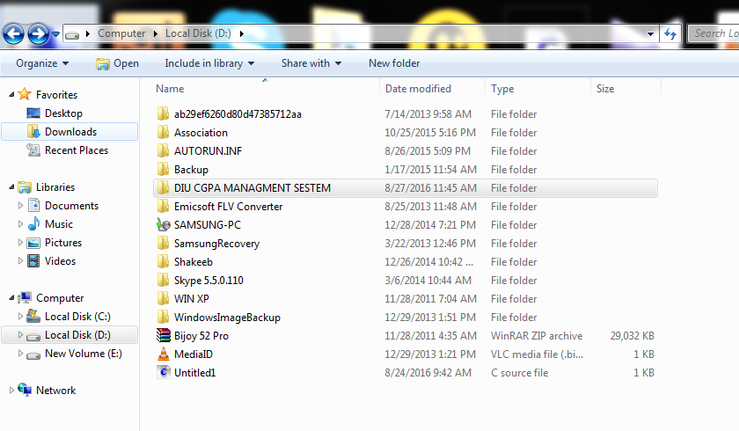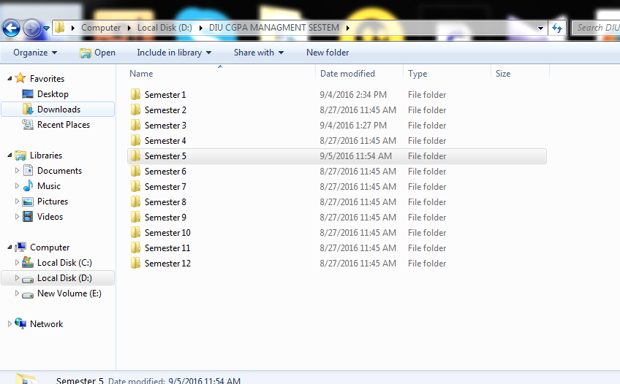

**Testing of the project**

|  |  |  |  |
| --- | --- | --- | --- |
| Test No | Test case | Expected Result | Result |
| 1 | ID input | Allow with hyphen character | pass |
| 2 | Name input | Will allow with space character | pass |
| 3 | Semester choosing | Check semester 1-12 | pass |
| 4 | Adding marks | Subject wise marks added | pass |
| 5 | Marks error check | If negative value given then program ask for the correct range of value | pass |
| 6 | Result | Result will show with grade latter and point | pass |
| 7 | Save | A .doc file will save in a specific directory | pass |

**Strong and weak points of the program**

After completing the project we found some strong and weak points of our program. We check all possible tests and all the stage it passed this is our strong point of our program. We entered different types of name, ids, marks and in all stages it took the value without any problems. And we also tested with file creating method all these steps are worked fine.

It has some weak point also, when we entered invalid key in all the subjects(e,f,/,*) its saying to input right value which is ok, but when it is calculating the cgpa box in its last subjects mark it will give a garbage value.

**Evaluation of our learning experience**

By completing this project we learn a lot of things of C programming language. We learn how to use strings, how to input someone's name with space character ,using of some specific function like "fgets" ,and also learn how to use “scanf” and “fgets” in same program, gather some knowledge of color code of print screen. How to clear screen after taking value it was very interesting part of our learning. We had worked a lot together that's why It made our work easy. Our code blocks knowledge is also increased while working with the project and we also knew some header file name which will very useful for others C project work.

We learn how to create a directory in a specific location and gather a knowledge how to put a file in that specific directory.

Gather a knowledge, how to create a file by user basis input.

By making this program we learn all kinds of basic things of “File input Output”.

If we run this program some computer doesn’t give permission to create the folder, so in that situation program needs to open with administrator. We also archive that knowledge, after that in our .exe file we rename it with “setup” than user doesn’t need to open with administrator it will automatically launched with administrator permission.

We create the folder with header file named “#define” so that reason our program is so accurate it always found the specific location. If we run the program keeping the program in the pendrive it will also found our location ” D://” Drive.

**Conclusion/Future work**

Our program has some future work. We have Decided we will create the program with html function so that, the result can be shown online. For that we need html header file and html syntax.

We also decided we will create a folder named “graduated student” in that specific location, when a student will complete his/her all semester quota in “graduated student” folder his/her name will automatic appear. And in its .html file his/her finishing result will be shown.